* Political Juggernaut- A quantitative Analysis of 2019 lok sabha election

Overview : Loksabha is composed of representatives of people choosen by direct election on the basis of universal adult suffrage.

Purpose : To give people’s a chance to choose the representatives

Problem statement and design thinking:A potential customers need a clearer understanding of next steps because the current page has a high bounce rate

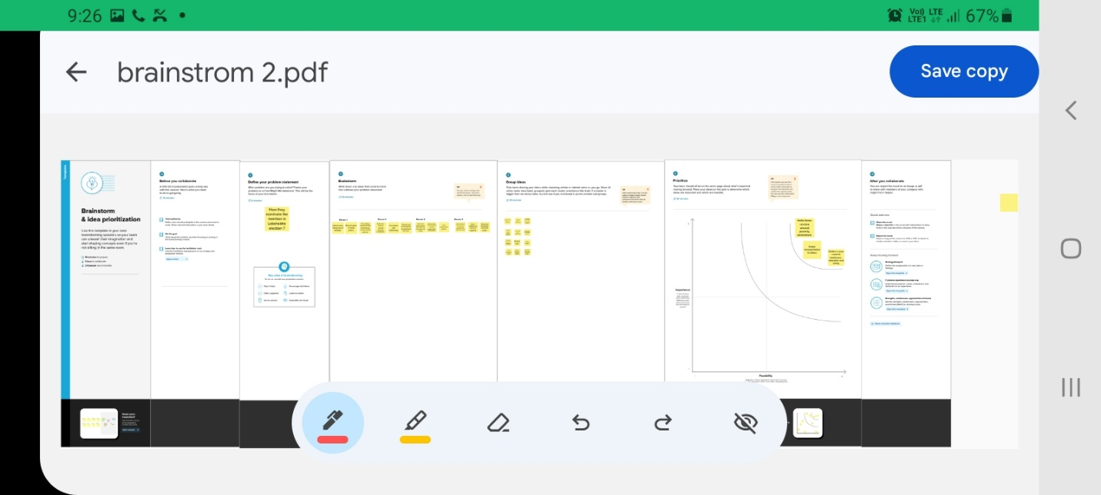

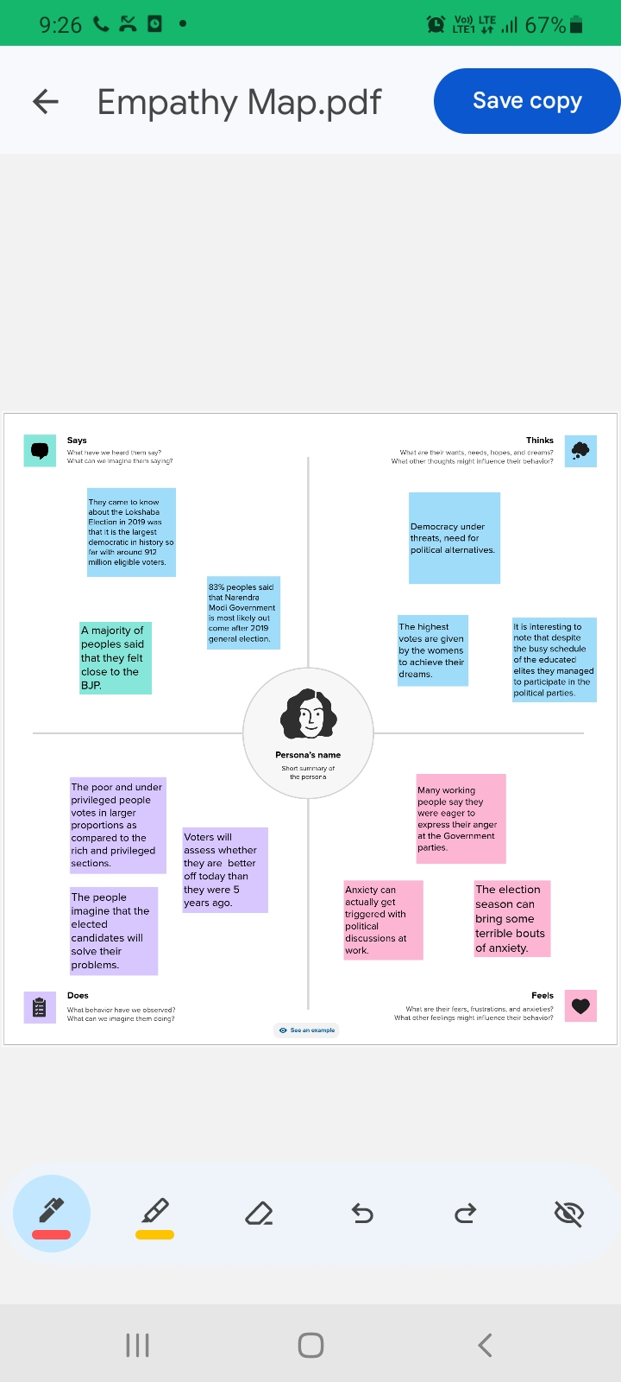

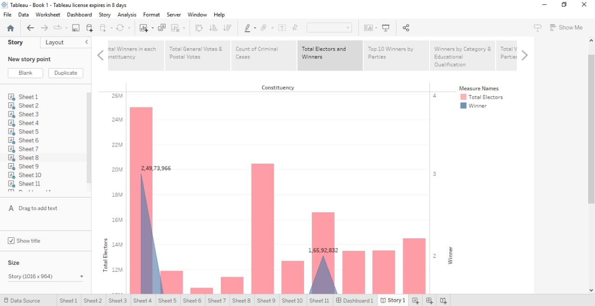 Results :

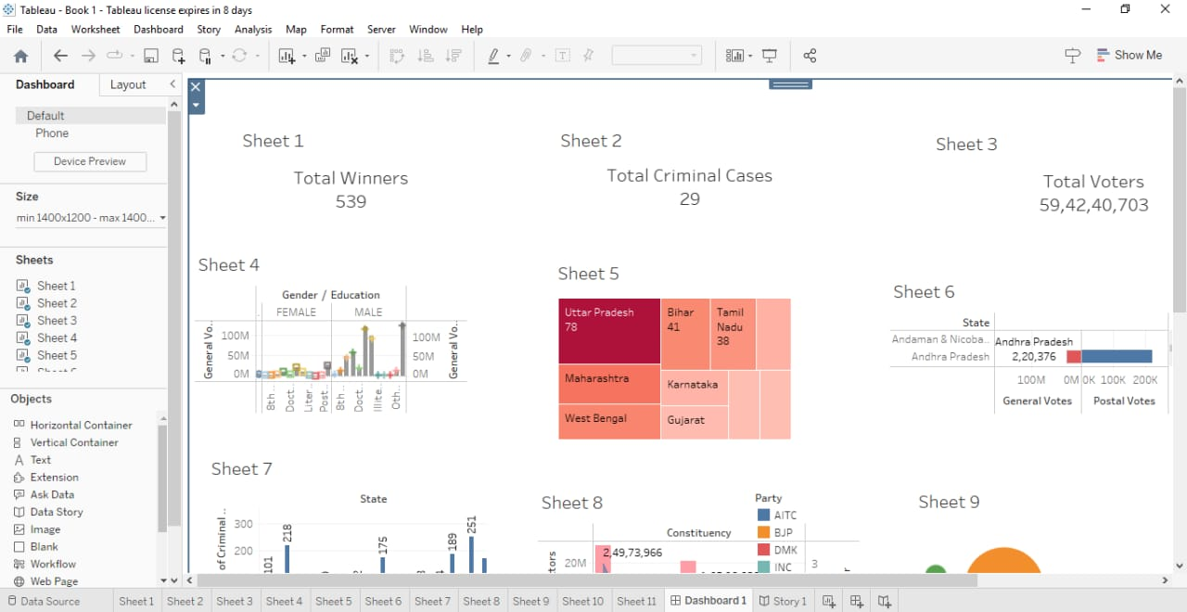Advantages and disadvantages:

1. Election also provide a platform for candidates share their ideas and policies with the public .
2. Voters do not have sophisticated knowledge and do not always make ideal policy decisions. Many voters are both uniformed about political issues and often use motivated reasoning because it is a short cut and most people do not have time to become a political expert.

Conclusion:

Voters casts a vote for any candidate that they approve of and all of these votes carry equal weight

Future scopes:

Global online voting system market future scope ,growth ,

analysis, forecast report.